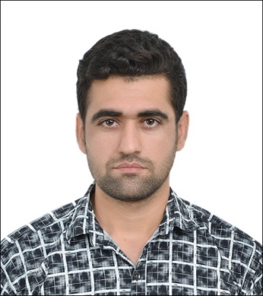

**Ajmal Naimi**

**CONTACTS**

53100 Jalan Gombak

International Islamic University Malaysia

Address

ajmalkhanqe@gmail.com

e-mail

+601121118197

Phone Number

**PERSONAL INFORMATION**

Born 11th Jan 1991 in zabul (Afghanistan) Marital status: Single

Citizenship: Afghan

**EDUCATION**

**2015/2016 sem1**

International Islamic University Malaysia

Electrical and Communication Engineering

Dean’s List student (CGPA**>**3.50) ‘certificate of appreciation’

**Feb 2012- Oct 2012**

Polytechnic University“faculty of Engineering”

**March-August, 2012**

Bakhtar Institute of Higher Education

Certificate achieved:Foundation Course

**August 2010** certificate of management training workshop

**December 2009**

Shikh mati high School zabul, Afghanistan

“12thGrade Graduation Certificate”

**MOTIVATION AND AMBITION**

* Responsible and disciplined person.
* A self-motivated person and able to compete with a strong motivation to succeed, an example of this is that among the students of Polytechnic University I got a fully funded scholarship from our government in Malaysia
* An active and punctual team member and will contribute to team working, as I understand it is important to work together share ideas and get feedback.

**SKILLS AND ACHEIVMENTS**

**Language: able to communicate in:**

* **English** excellent in (writing, reading, and speaking)
* **Pashto** Native tongue
* **Urdu** good in (writing, reading, and speaking)
* **Dari** good in (speaking and listening)
* **Bahasa Melayu** fair

**Computer skills:**

* MS Windows
* Microsoft Word.
* Microsoft power point.
* Solid work
* Basic C language.
* Matlab

**Technical skill in laboratory:**

* Basic knowledge on laboratory equipment and usage.

**Work and experience**

* **08 April 2010** Business management entrepreneurship and career development ( 3-moths practical work )
* **5 January 2011** a site supervisor with CDG (city demand group) organization (3-moths)
* **3 May 2011** a cashier of local football federation of Zabul (2-months)